

|  |
| --- |
| Canada Crime Stats 2021 |
|  |
| July 6  Data 2205 – Data Visualization Assignment 2  Author: Raj Dholakia |

K.

Analytics

# Table of Contents

Table of Contents ii

Introduction 1

Summary of the presentation 1

Methodology 2

Visualization Tool 2

Data Analysis Approach 3

Stage 1: Data Pre-processing 3

Stage 2: Data Visualization 4

Key Findings 5

How does violent crime in the three provinces compare? 5

Crime Rate Predictions 14

Conclusion 17

References iii

# Introduction

|  |
| --- |
| Summary of the presentation Royal Canadian Mounted Police (RCMP – Federal Police) would like to improve collaboration and support between the Peace Officers operating in different provinces to reduce crime in Canada. RCMP intends use the crime statistics of Ontario, Quebec and Manitoba for the last 10 years to gain insights and add to their collaboration initiative. Officer Richard is appointed to overlook the project.  Officer Richard expects a formal presentation that achieves the following objectives:   1. Compare the crime rates between Manitoba, Ontario, and Quebec in the last 10 years. 2. Compare the crime rates for the top 3 cities for Manitoba, the top 3 cities for Ontario, and the top 3 cities for Quebec with the highest crime in the last 10 years. 3. Determine if there is a correlation between youth crime and adult crime for each high crime rate city. 4. Determine the crime rate for next year for Manitoba, Ontario, and Quebec. |
| *Perform data analytics on Canada’s crime statistics dataset to improve police operations in different provinces.* |

# 

# Methodology

This section will highlight the tools and techniques used to achieve the objectives required.

Understanding the basic characteristics of the dataset will provide the information needed to select an ideal tool and technique for the analysis problem. First impressions of the crime statistics dataset provided by RCMP reflect the following:

1. The dataset is very large – about 2GB per province.
2. There are three dimensions the crime dataset is divided into:
   1. Geography
   2. Violations
   3. Statistics

These characteristics of the dataset will be important as the ideal visualization tool and the optimum data analysis approach as selected.

## Visualization Tool

Officer Richard has requested for a formal presentation containing visualizations, hence selecting a visualization tool for the process is an important step. From the first impressions of the dataset, we know dealing with this dataset will require a considerable amount of data manipulation. The chosen visualization tool should be able to provide the functionality to transform data. Hence, the two market leaders are shortlisted:

1. Tableau – *Tableau Prep*
2. Microsoft PowerBI - *PowerQuery*

As the dataset is large Tableau should be an ideal choice, but it is not cloud-native. If the RCMP intends to deploy the visualizations on a larger scale to provide insights to Peace Officers in different provinces, Tableau will not be able to support that. On the other hand, Microsoft PowerBI’s integration with Teams and other Microsoft apps provides has an added flexibility in functionality along with scalability. Furthermore, Microsoft PowerBI has one of the best price-to-power combinations in the market, comparatively, Tableau is more expensive.

Hence, the ideal visualization tool for the data analysis problem is **Microsoft PowerBI**.

## Data Analysis Approach

The data analysis process will be divided into two major stages:

1. Data Pre-processing
2. Data Visualization

Decisions taken at both these stages will take into consideration the deliverables of the analysis.

### Stage 1: Data Pre-processing

In this stage, the data will be loaded and transformed using PowerQuery. The goal is to prepare the dataset to be loaded into PowerBI to create visualizations.

As the dataset is very large, it will be filtered to keep only the variables that will be used in the visualizations. The three dimensions of the dataset (geography, violation, statistics) will be considered to filter the dataset.

The following points will be used to filter the data:

* Last 10 years of data.
* **Geography** | Top 3 cities for each province with the highest crime in the last 10 years.
* **Violations** | Out of 317 violations, the following are selected:

1. Total, all violent criminal code violations

* **Statistics** | Out of 16 statistics, the following are selected:

1. Total, persons charged – measure of total crime
2. Total, adults charged – measure of adult crime.
3. Total, youth charged – measure of youth crime.
4. Total, youth not charged – measure of youth crime.
5. Rate per 100,000 population – alternate measure of total crime.

All the above variables are selected based on the expected deliverables. Ideally, a Peace Officer would like to first reduce violent crimes in a vicinity and then follow up by reducing non-violent crimes. Hence, this report will take into consideration “Total, all violent criminal code violations” for the analysis.

Another important consideration for the report is using “Total, youth not charged” for estimation of youth crime (Objective #3). The sum of “Total, youth charged” and “Total, youth not charged” will give a better approximation of the “Total, all violent criminal code violations” by youth (aged 12-17) than just considering only “Total, youth charged”.

Finally, to determine the top 3 cities with the highest crime in each province (Quebec, Ontario and Manitoba), a python code will be used. A python function is created to carry out data manipulation to get the top N cities for the defined geography, violation and statistic. All the code is written in a Jupyter notebook and can be found in the project’s [GitHub repository](https://github.com/radroid/crime-stats-assignment-2).

### Stage 2: Data Visualization

This stage involves creating different visualizations to communicate the required objectives defined by Officer Richard.

# Key Findings

## How does violent crime in the three provinces compare?

Figure 1: Persons Charged for Violent Criminal Code Violations by Province

* Ontario has the highest number of violent criminal code violations through the last 10 years, consistently.
* Ontario is followed by Quebec, while Manitoba has the lowest number of violations through the last 10 years.
* All three provinces witnessed their 10-year lowest crime rates in 2014.
* Quebec saw a sharp rise in crime between 2018 and 2019 – about 34.3% rise in violent criminal code violations.

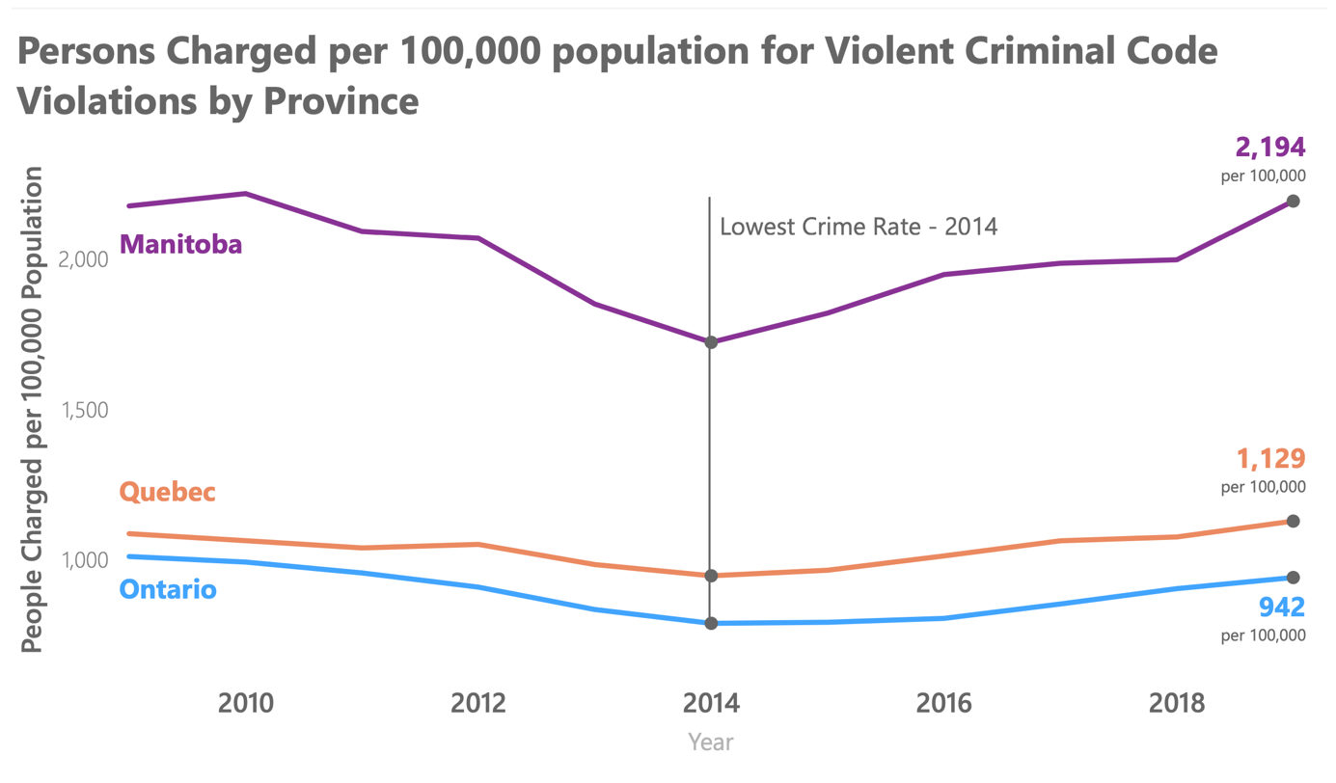Generally, higher the population of a province, higher the number of persons charged. However, will the outlook change if we adjust the violations for the population of a province?

* Manitoba has the highest number of violent criminal code violations per 100,000 population through the last 10 years, consistently. It is almost 2 times that of Quebec that is second.
* When adjusted for the population, Ontario falls from being the province of high importance to the one with the lowest crime rate among the three provinces.
* Even with adjusted population, all three provinces witnessed their 10-year lowest crime rates in 2014.
* Manitoba has seen high fluctuations in the crime rate through the 10 years, achieving its highest in 2019.

Figure 2: Persons Charged per 100,000 population for Violent Criminal Code Violations by Province

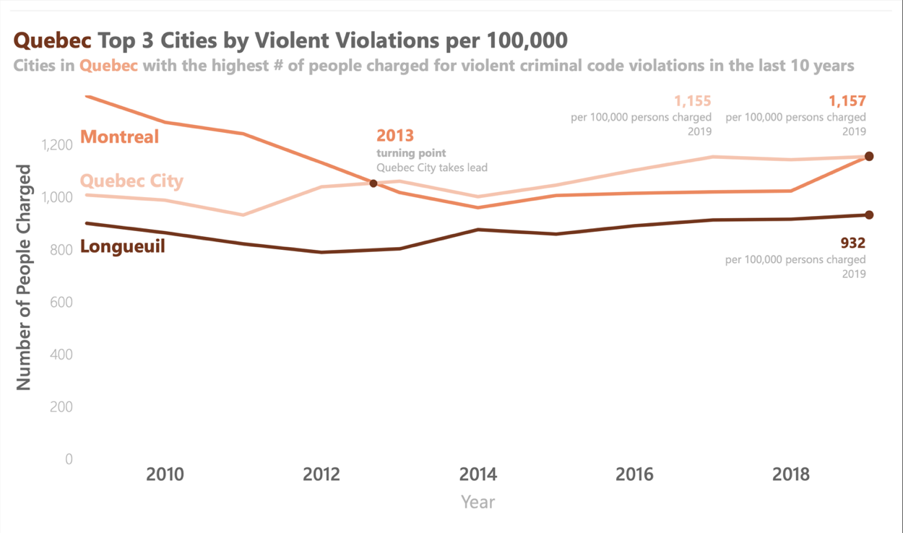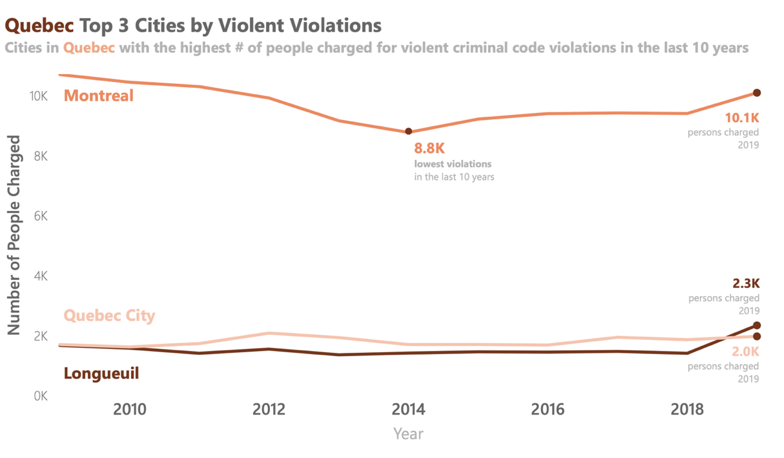

Considering the number of violent violations:

* Montréal, Québec City and Longueuil have the highest crime in the province of Quebec.
* Montréal almost 5 times the number of people charged for violent criminal code violation compared to the other two cities in 2019.
* Québec City has the second highest number of violations till 2019, when Longueuil takes records higher crime.

Considering violent violations per 100,000:

* When adjusted for the population, Montréal and Québec City compete for the top spot.
* Montréal has the highest crime in the province till 2013, when Québec City takes over and in 2019, Montréal retains the spot.
* Longueuil has a consistent crime rate per 100,000 population through the last 10 years.

Figure 3: Quebec Top 3 Cities

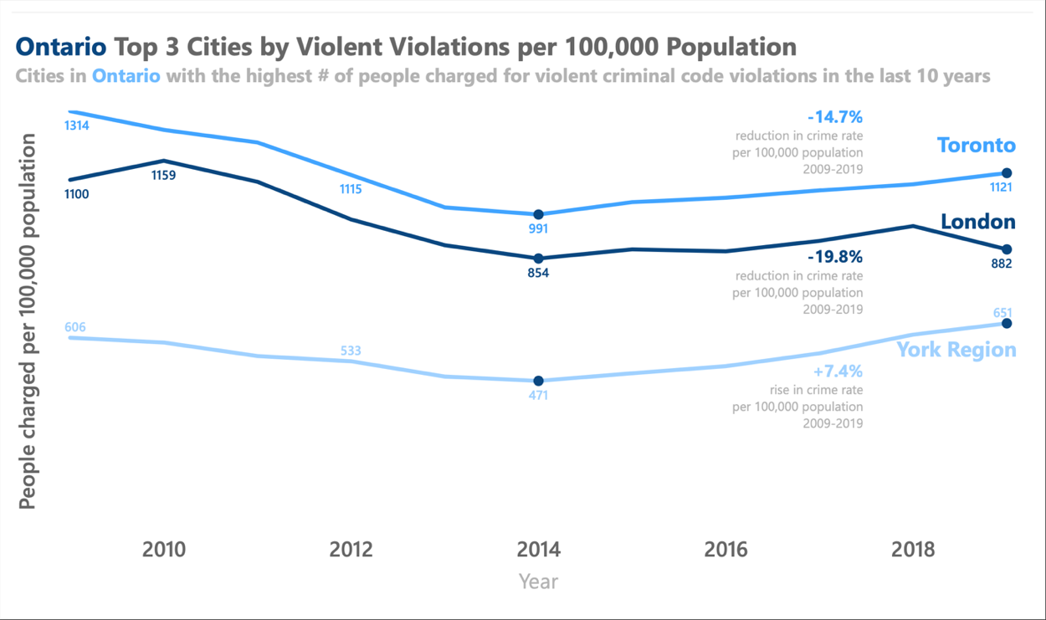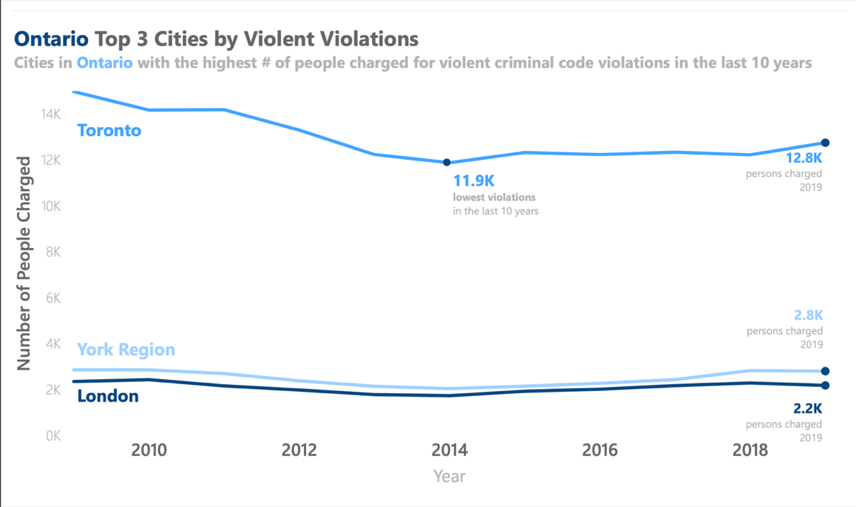

Figure 4: Ontario Top 3 Cities

Considering the number of violent violations:

* Toronto, York Region and London have the highest crime in the province of Ontario.
* Toronto almost 6 times the number of people charged for violent criminal code violation compared to London in 2019.
* The relative ranks for all three cities remain constant throughout the 10-year period.

Considering violent violations per 100,000:

* London takes over York Region for the second highest crime rate among the three cities.
* A downtrend in crime is observed for Toronto and London, reducing by 14.7% and 19.8%, respectively.
* York region sees a decrease in the first 5 years, but increases in the last 5 years, resulting in an overall increase of 7.4%.

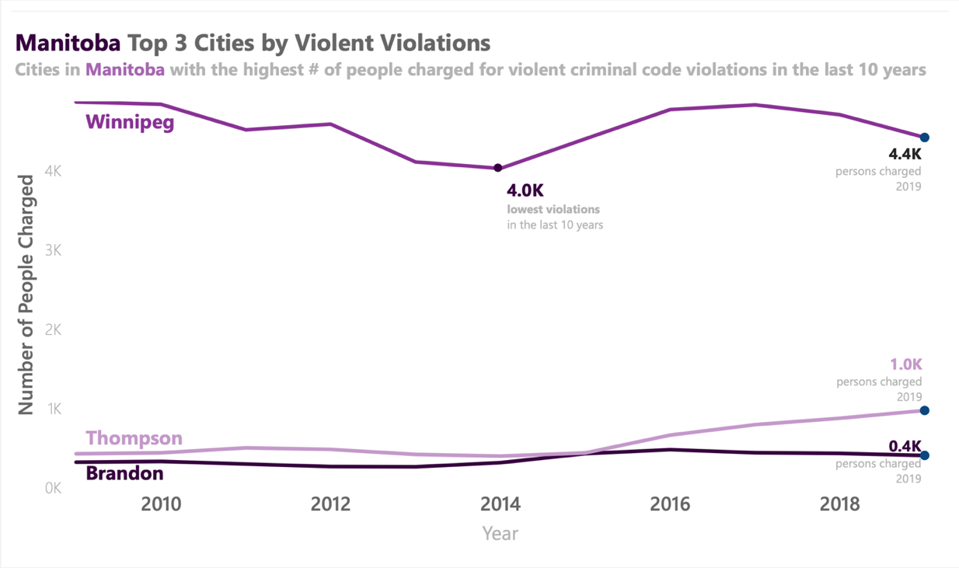

Considering the number of violent violations:

* Winnipeg, Thompson and Brandon have the highest crime in the province of .
* Winnipeg 4.4 times and 10 times the number of people charged for violent criminal code violation compared to the Thompson and Brandon in 2019, respectively.
* The relative ranks for all three cities remain constant throughout the 10-year period.

Considering violent violations per 100,000:

* The scenario completely changes. Crime in Thompson is almost 20 times more than the Brandon and Winnipeg in 2019.
* Furthermore, Thompson observes over a 100% (2 times) increase in the number of violent criminal code violations between 2009 and 2019.
* Winnipeg and Brandon have a similar crime rate throughout the 10-year period.

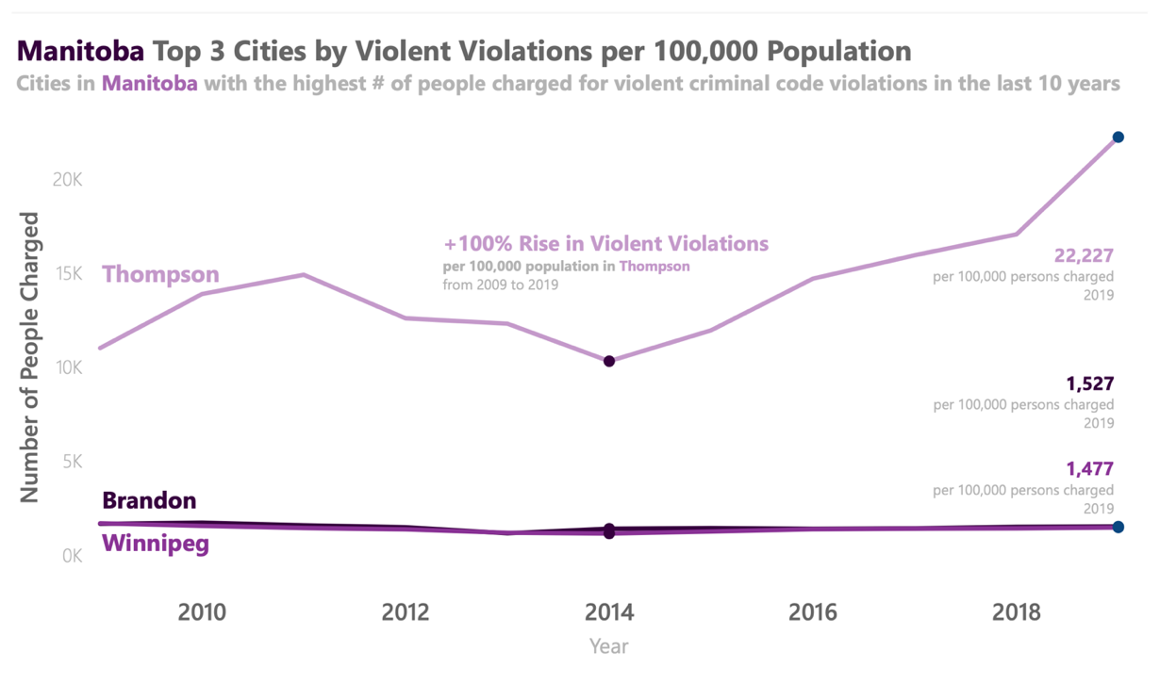

Figure 5: Manitoba Top 3 Cities

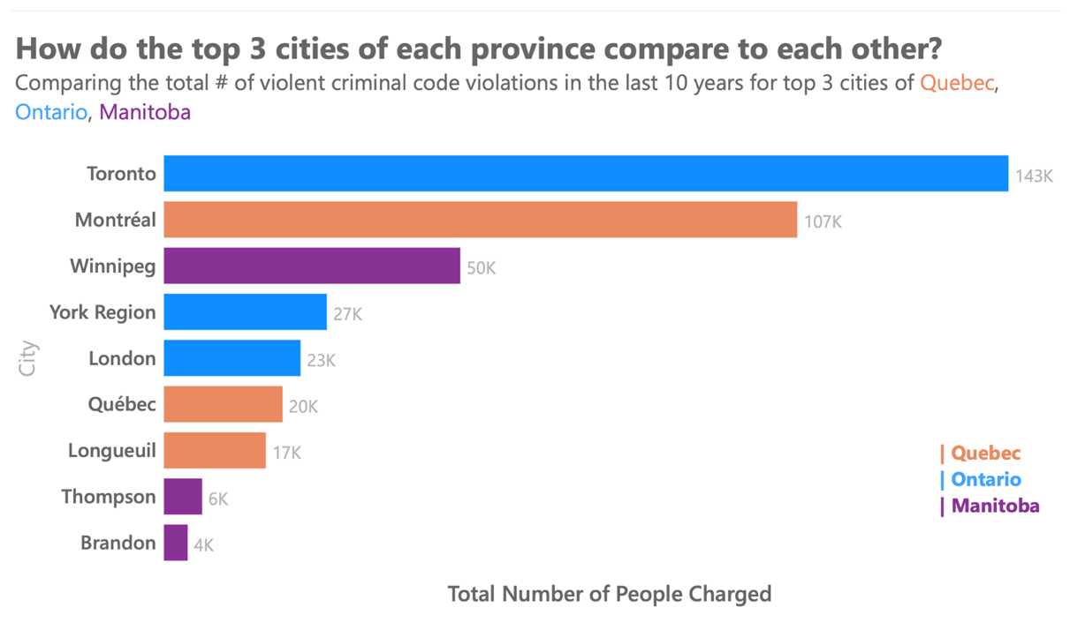

Considering the number of violent violations:

* Toronto, Montréal and Winnipeg have the highest crime in the three provinces.
* There is clear trend that cities in Ontario in general are above the cities in Quebec and Manitoba, respectively.

Considering violent violations per 100,000:

* The cities of Manitoba take over the cities of other two provinces.
* Thompson has a very high crime rate when considering per 100,000 population statistic, about 10 times more than Brandon, that is second on the list.

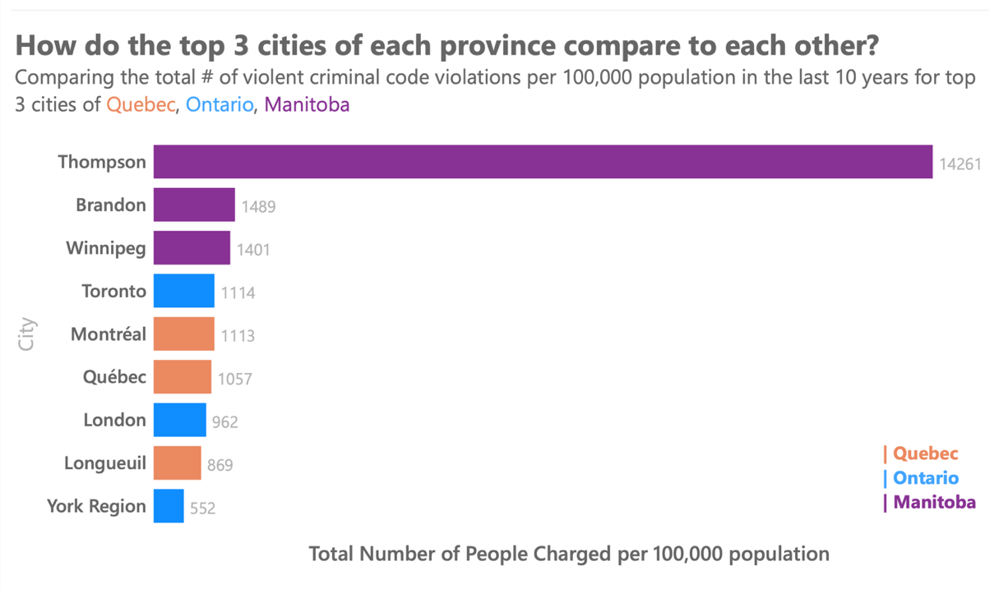

Figure : How do the top 3 cities of each province compare to each other?

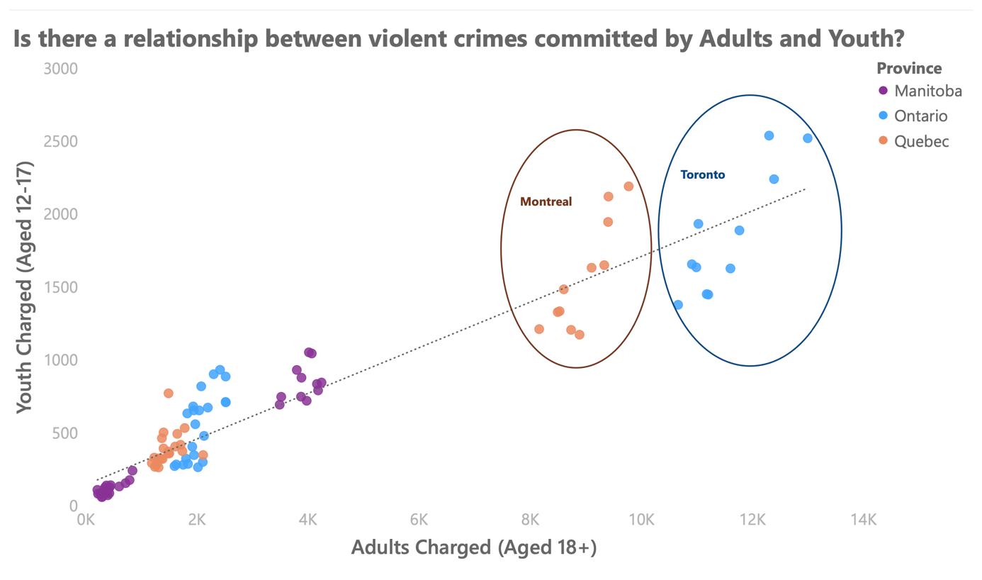

Figure 7: Is there a relationship between violent crimes committed by Adults and Youth? - 1

* A positive correlation is observed between youth crime and adult crime.
* Two specific cities, Montréal and Toronto are identified in the scatter plot that seem to have a clear positive correlation in the dataset.
* Generally, a correlation between the two variables, youth crime and adult crime, highlights the possibility of violent criminal code violations at a small age (youth crime) affecting the person when he/she becomes an adult.
* However, this trend cannot be confirmed with the available data as there is are many other factors could cause the variables to be correlated, such as, influence of violent crimes committed by adults on youth.

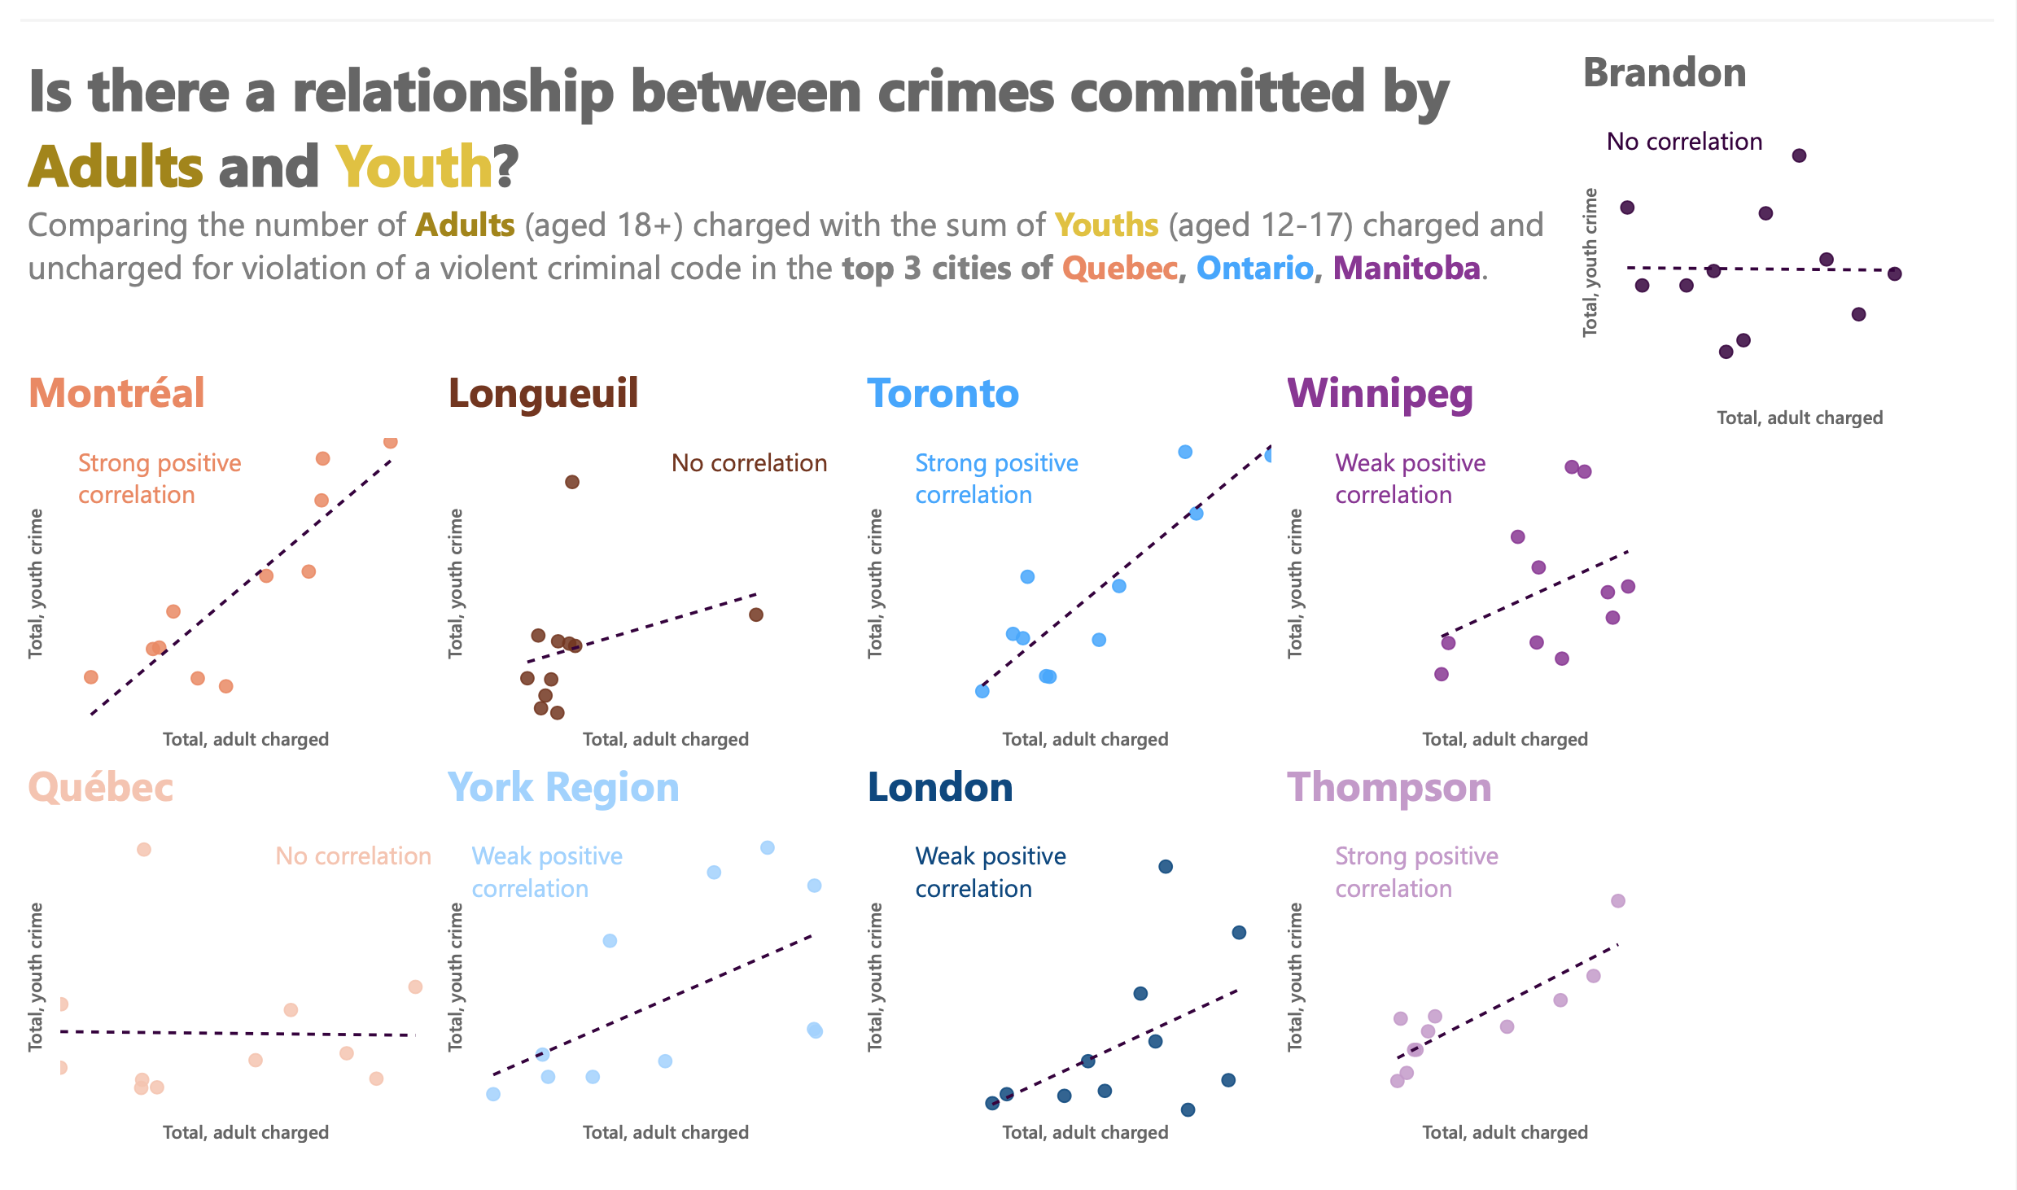

1. Montréal, Toronto and Thompson have strong positive correlations.
2. York Region, London and Winnipeg have weak positive correlations. While, Québec City, Longueuil and Brandon observed no correlation in the dataset.

Figure 8: Is there a relationship between crimes committed by Adults and Youth? - 2

1. From correlation plots for each of the top 3 cities for Quebec, Ontario and Manitoba, a difference in correlations between youth crime and adult crime is observed.

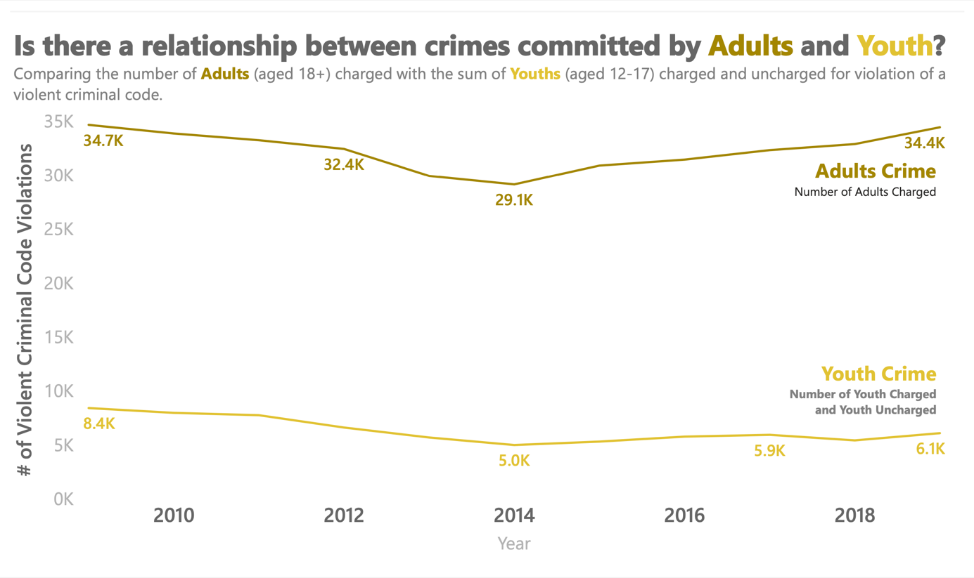

Figure 9: Is there a relationship between crimes committed by Adults and Youth? - 3

* In this figure, as observed when comparing crime in provinces, the crime rate is lowest in 2014.
* A slight correlation is observed in the change in youth and adult crime.
* Data for about 20 years needs to be studied to proves that the underlying reason for the correlation is not youths growing up and violating violent criminal codes.
* However, the time series highlights the possibility of there being a weak correlation between the two statistics.

# Crime Rate Predictions

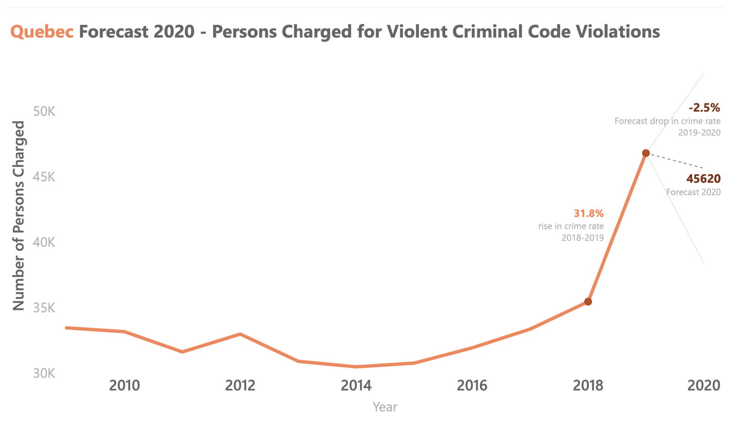The predictions in this section are calculated using PowerBI’s forecasting capability. The model uses historical trends to predict a value for the year 2020. As the historical data is limited, the predicts are not very accurate. A 95% confidence interval is shown on each graph as two lines stretching above and below the predicted value.

Figure 10: Quebec Forecast 2020

Crime in Quebec is expected to decrease by 2.5% in the year 2020. However, observing the rise of crime by 31.8% between 2018 and 2019, shows that the prediction might not be accurate and the crime might be on the rise instead of decreasing.

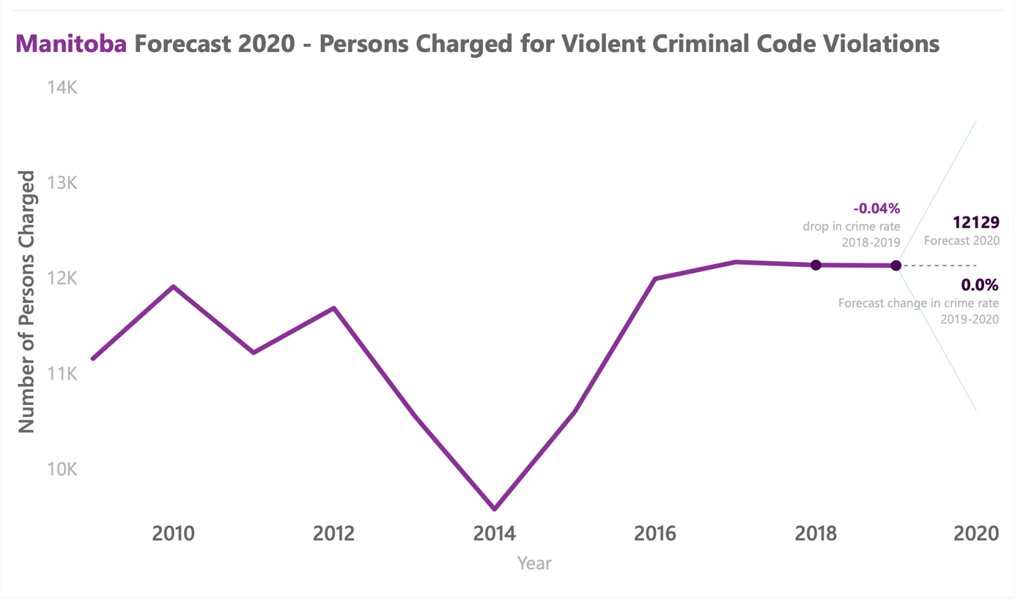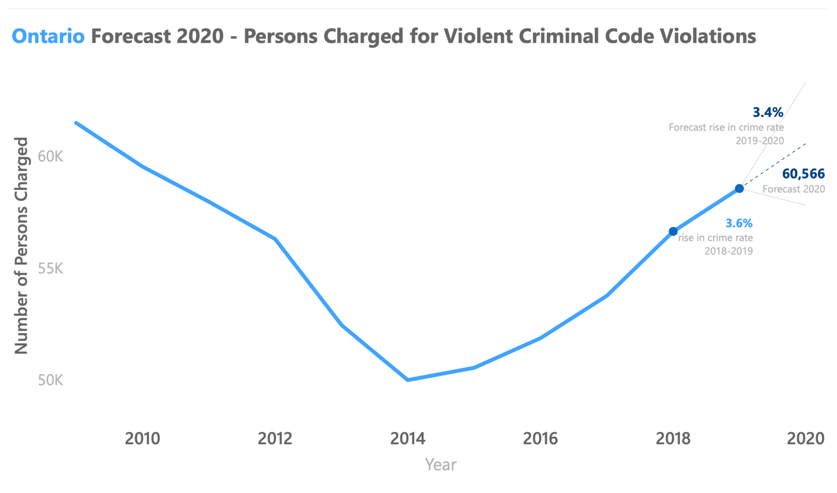The number of violent criminal code violations in Ontario for the year 2020 is predicted at 60,566. This is a 3.4% increase in crime from 2019.

Figure 11: Manitoba Forecast 2020

Figure 12: Ontario Forecast 2020

From the trend in the recent years, Manitoba expects a stagnant crime rate for the year 2020. Since 2017, Manitoba has had an almost constant number of violent criminal code violations.

# Conclusion

From the data, it is evident that RCMP should focus on Montréal, Toronto and Winnipeg when looking at the number of violent criminal code violations. However, it is also important to look at the number of violations adjusted for the population to develop an understanding of what is the Peace Officer-to-population ratio is required in each of the provinces.

From the predictions, RCMP keep an eye on crime levels in Ontario as it could rise by 7.8% for the year of 2020, while crime in Manitoba seems to be stagnant. Finally, though Manitoba has the lowest crime number among the three provinces, the high crime rate per 100,000 population in Manitoba might require some attention.

# References

**Data from** [**https://statscan.gc.ca**](https://statscan.gc.ca):

*Ontario Crime Stats*: <https://www150.statcan.gc.ca/t1/tbl1/en/tv.action?pid=3510018001>

*Quebec Crime Stats*: <https://www150.statcan.gc.ca/t1/tbl1/en/tv.action?pid=3510017901>

*Manitoba Dataset:* <https://www150.statcan.gc.ca/t1/tbl1/en/tv.action?pid=3510018101>

Data 2205 – Data Visualization Assignment 2 Description